CC2020 report – page 49

4.2.4: Component Elements

A competency is a collection of specific components of knowledge, skills, and dispositions. Tables 4.1, 4.2, 4.3, and 4.4 present suggested elements of these dimensions. The knowledge dimension of competency encompasses concepts that are technical (computing concepts), foundational and professional (indicative of a workplace), and domain specific (the task setting). Appendix D elaborates on these component tables in greater detail.

Table 4.1 illustrates thirty-four abbreviated knowledge areas partitioned into an ordered sequence of six categories.

While the table is incomplete, it does provide an example of high-level vocabulary for computing knowledge rooted in the collective wisdom of different computing communities.

This summary of computing knowledge areas represents a well-understood and consistent vocabulary from which computing competency statements can evolve.

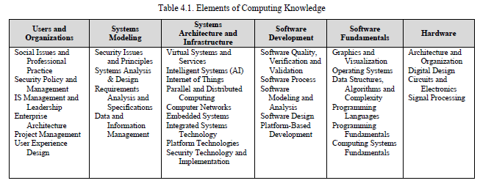

The thirteen elements of foundational and professional knowledge listed in Table 4.2 represent a subset of the professional listings derived from the IT2017 report and subsequently from Appendix D in this report. Computing professionals are commonly expected to demonstrate high levels of skill in applying this knowledge which desserves explicit attention in baccalaureate programs.

Domain knowledge represents elements of the context that situates the task. In the general, these elements may represent the disciplinary (e.g., business, medicine, manufacturing). In the more detailed, they may be more specific (e.g., international currency exchange, radiographic imaging, automobile assembly). In any case, the scope and level of detail of domain knowledge will emerge from the intended use of the competency (i.e., Computing + X or X + Computing, for which see Section 2.4).

